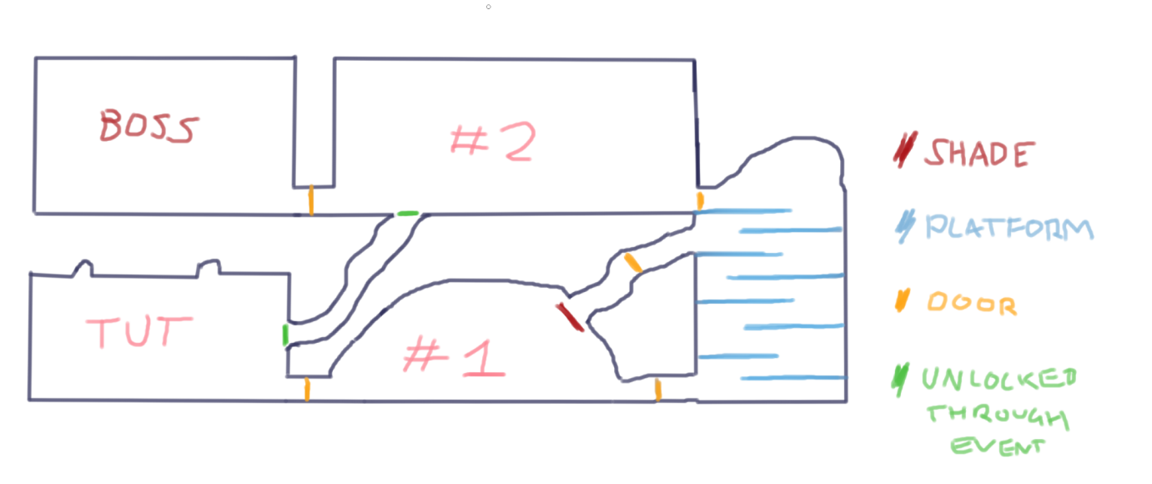List of songs we will need:

* Inspiration: Hollow Knight
* First room
  + Return to again and again
  + Spooky looking dungeons, very cavernous
  + Emotions: - similar feelings to Dirtmouth
    - The player will have either just died or will have just started the game, so a little sad
    - The player should feel that they have some hope – (“Damn I lost, but maybe I can do it this time!”)
* Levels
  + #1 is a cavern – Forgotten Crossroads
  + #2 and platforms will be coming out of the caverns and into a great palace
  + There will be enemies and platforming challenges to test the player
* Boss fight
  + (Description I gave Zeb) The boss is both highly trained and extremely aggressive. He knows how to fight well, but he desperately wants to kill the player. When the player enters the room for the first time a cutscene will play showing the Boss laying into a previous opponent, really throwing them about.
* Main menu